**Azure Arc**

1. Azure Arc is a Microsoft tool that helps you to manage and secure your resources across different places like your own servers, other cloud services (AWS,GCP), and devices like computers. It lets you use familiar Azure tools to control everything easily.
2. Go to Azure portal Navigate to marketplace à Go for Azure ARC (search for azure Arc)

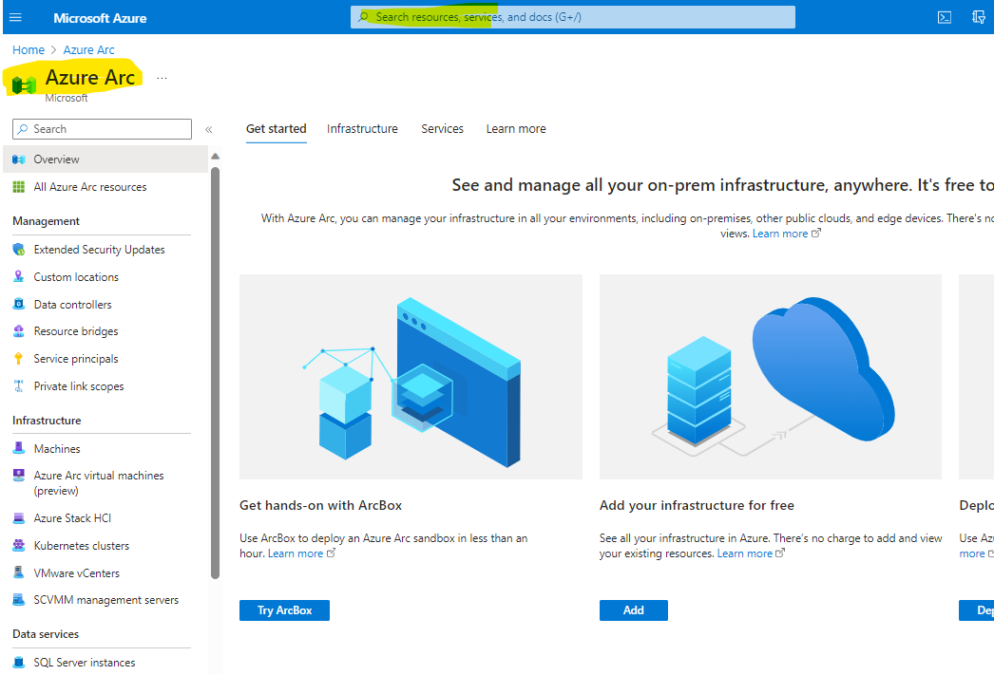

àselect Machines from the menu bar

à Click on the Add/Create option

àChoose Add Machine option

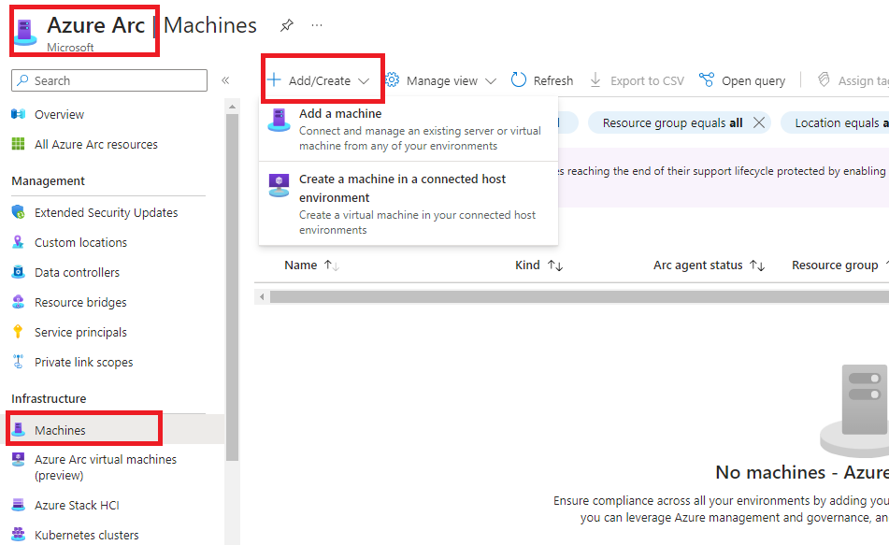

1. Generate the Script

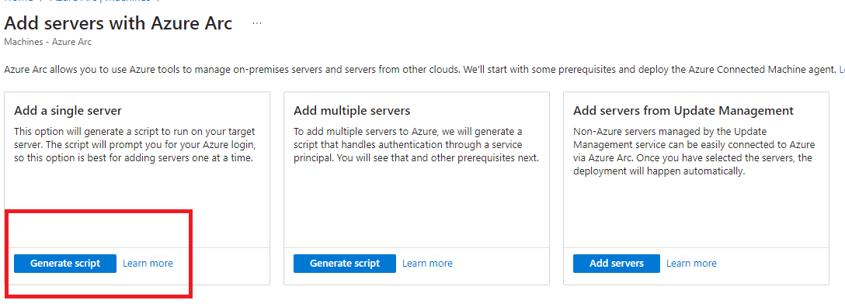

1. Fill the required details such as Subscription, Resource group, Machine type (Windows/Linux), download the script.

1. The script will be downloaded to our local machine.

1. Go To N-able, choose the device needed to onboard to Azure, log to that device, and open Windows PowerShell ISE, run as administrator.

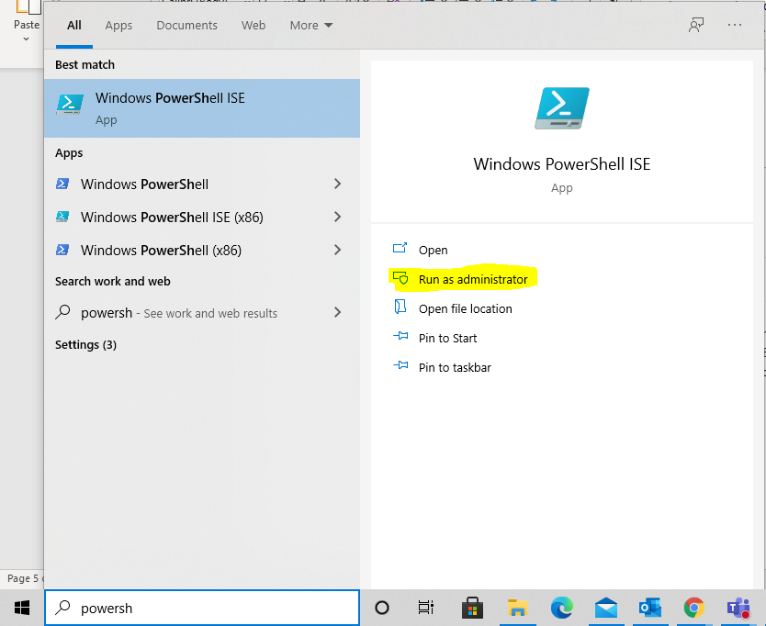

--> Go to file option open downloaded file (step –5)

Run the script --> Machine will be onboarded to azure.

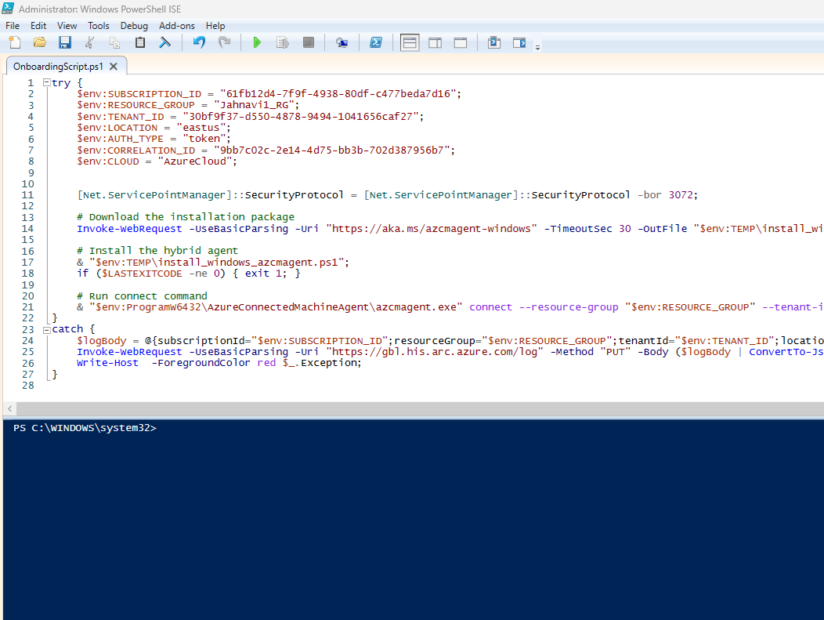

1. If you get this type of error your PowerShell restricts the running scripts so we have to Un restrict it by using following cmd.

>> Get-ExecutionPolicy

>> Set-ExecutionPolicy unrestricted.

And try to run the script.

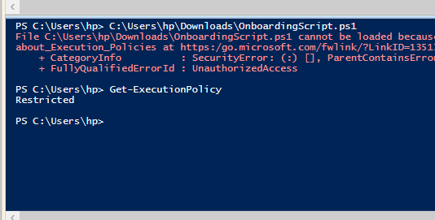  
 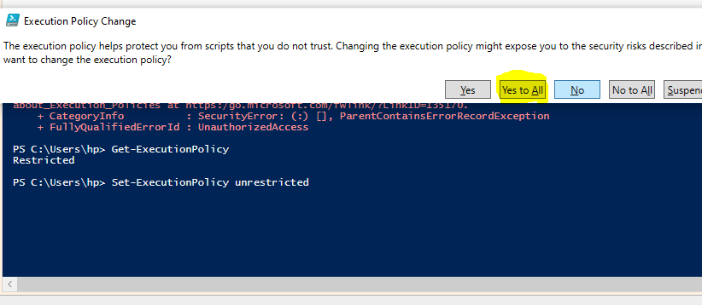

1. After successfully running the script you will find the link and code as shown in below screenshot. Copy that link and open the browser and paste it. You will see this Enter Code window and enter the Code.

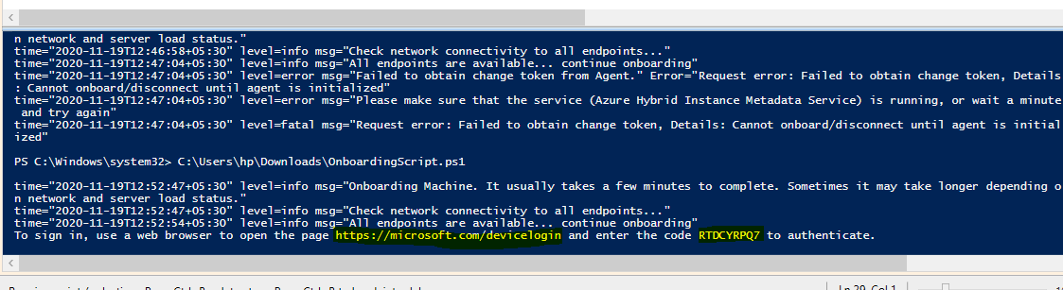

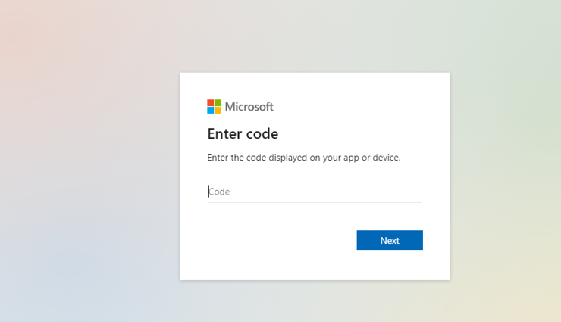

1. After entering the code you have to select an account.

1. Once you choose the account you will see that Azure connected machine successfully.

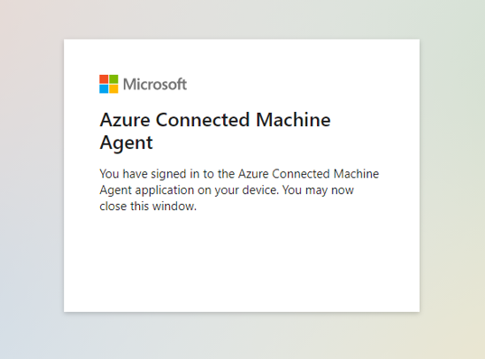

1. Check the portal in Azure ARCàMachines. You will find the machine.